CSE220: Data Structures (Lab)

Fall 2024

Lab Quiz - 05

Duration: 30 Minutes

| Name: | ID: | Section: |
| --- | --- | --- |

### **Question 1 [15 Points]**

In this task you are given a BST, and you are asked to find a particular destination and the navigation path from the root to that destination. If the destination exists in the BST then , we will show if we need to go left or right in each step to reach the destination. If the destination does not exist then we will simply say that the route does not exist.

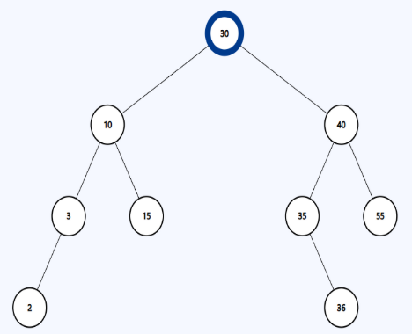Let's say you are given the following BST

| **Sample Input** | **Sample Output** | **Explanation** |
| --- | --- | --- |
| route(root,36) | Go right  Go left  Go right | 36 is at the right subtree of 30, so we go right  36 is at the left subtree of 40, so we go left  36 is at the right subtree of 35, so we go right |
| route(root,60) | Go right  Go right  60 does not exist. | 60 should be at the right subtree of 30 60 should be at the right subtree of 40  60 is not at the right or left of 55. So not found |

**You need to construct the node class and the BST by yourself.**